**UNIVERSITY OF ENGINEERING AND TECHNOLOGY PESHAWAR, JALOZAI CAMPUS**

**LAB 01**

1. **Install IDE**

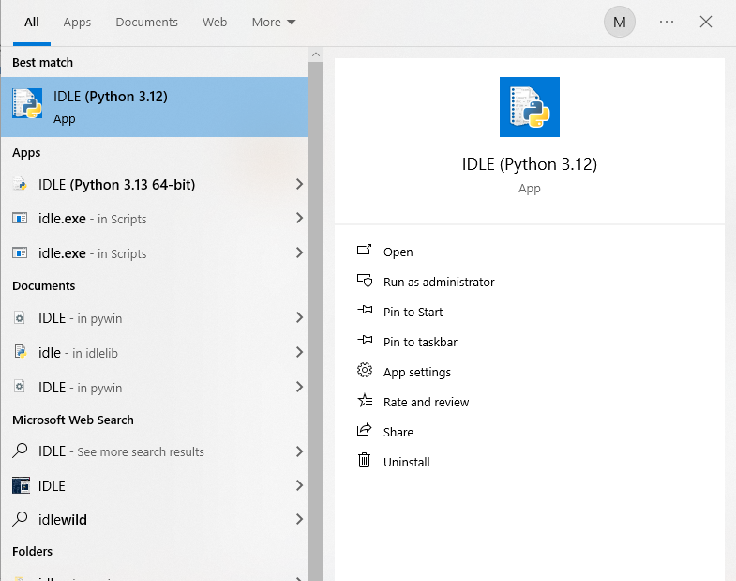

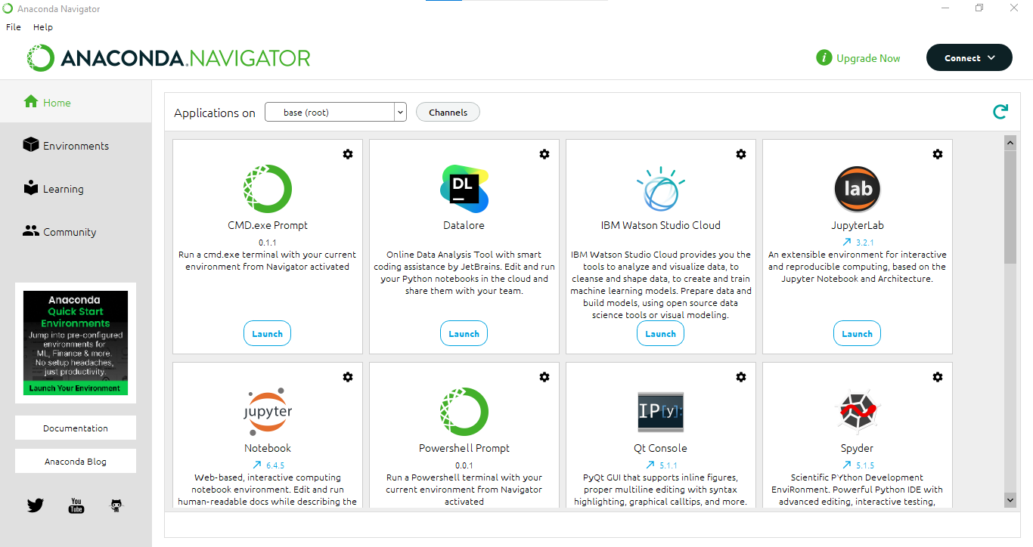

1. Make a GitHub account.

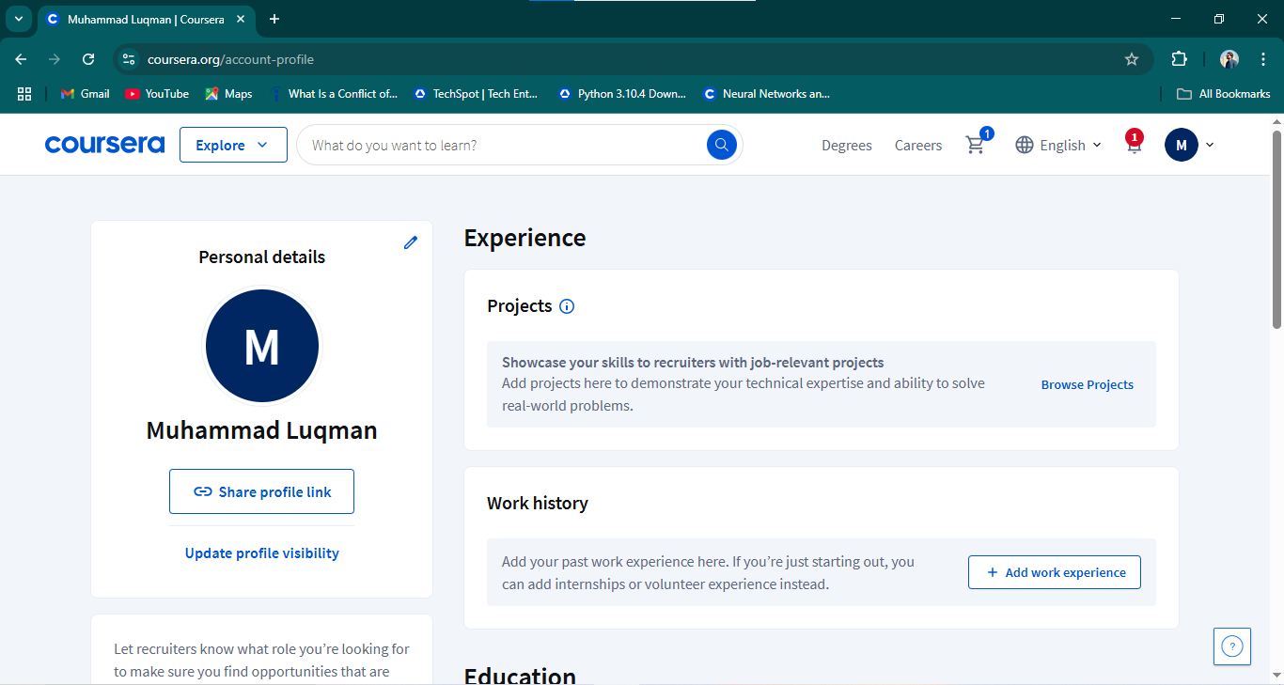

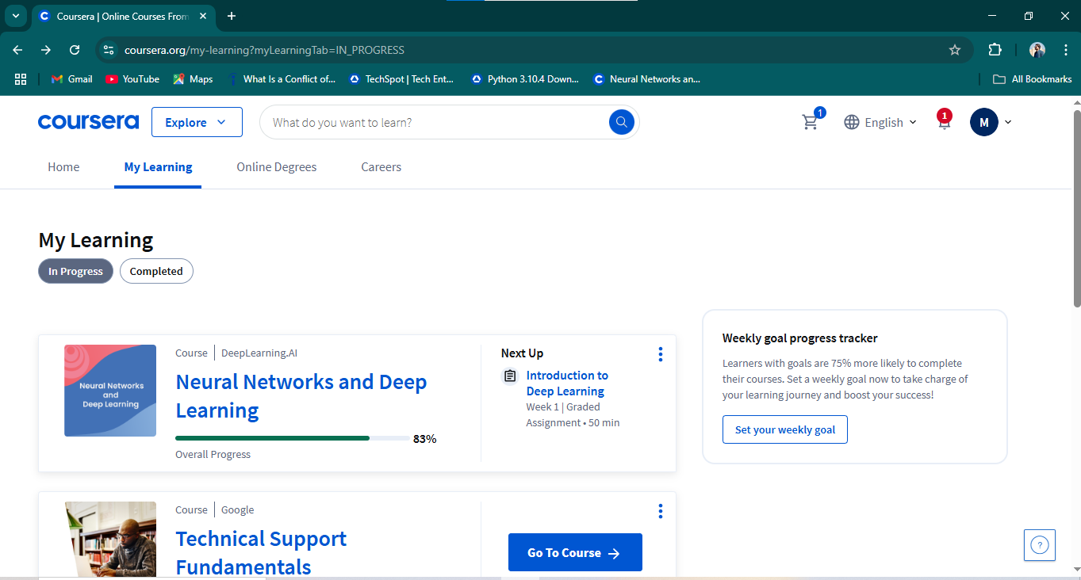

1. **Jupyter Notebook:**

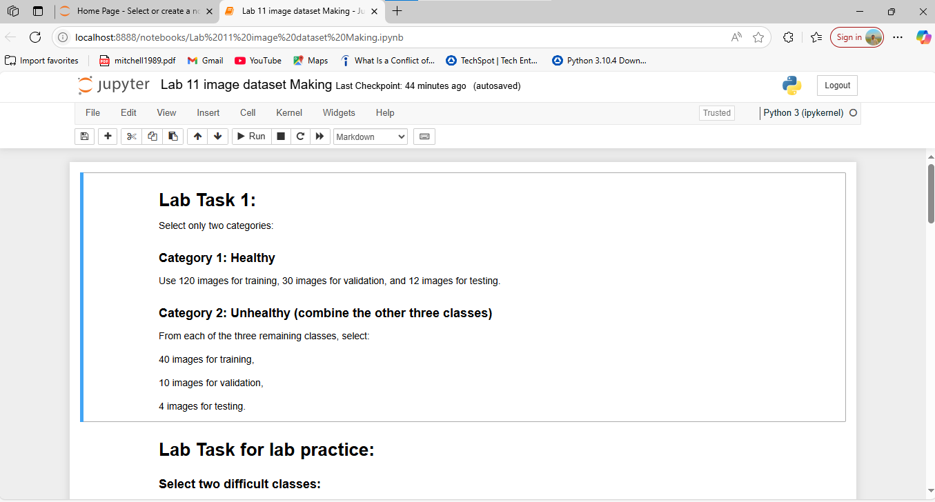

1. 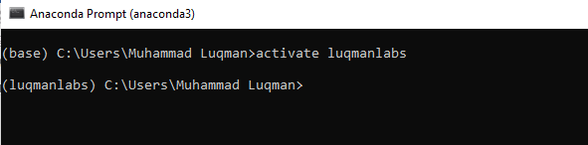**Virtual environments**